**IB Math SL 2/ AB Calculus AB Midterm Review**

1. If  then 

(A) (B) (C) (D) (E)

2. For  the horizontal line is an asymptote for the graph of the function *f*. Which of the following statements must be true?

(A) (B)  (C) is undefined (D) (E)  for all 

3. If  then 

(A) (B)  (C)  (D)  (E)

4.

(A) 4 (B) 1 (C)  (D) 0 (E) -1

5. If, then 

(A)  (B)  (C)  (D)  (E) 

6. If is

(A)  (B)  (C)  (D)  (E) nonexistent

7.

(A) dne (B) (C) (D) 0 (E)

8. What is the slope of the tangent to the curve  at the point (3, 2)?

(A) 0 (B)  (C)  (D)  (E) 

9. =

(A)  (B) 

(C)  (D)  (E) 

10. Let *f* be the function with ***derivative*** given by  On which of the following intervals is *f* decreasing?

(A)  (B)  (C)  (D)  (E) 

11. Find if



(A) (B) 



(C)  (D)  (E) 

12. Let *f* be the function given by . The graph of *f* is concave down when

(A)  (B)  (C)  (D)  (E) 

13. Find 

(A) 41 (B) 17 (C) 11 (D) 0 (E) 2

14. Let. Which of the following statements are true about *f*?

I.  exists II. *f* is continuous at  III. *f* is differentiable at 

(A) None (B) I only (C) II only (D) I & II only (E) I, II, & III

15. The second derivative of the function *f* is given by . The graph of  is shown below. For what values of *x* does the graph of *f* have a point of inflection?

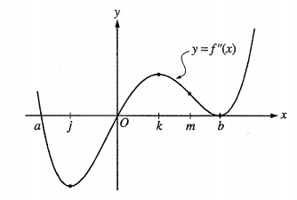

(A) 0 & *a* only (B) 0 & *m* only (C) *b* & *j* only (D) 0, *a,* & *b* (E) *b, j,* & *k*

16. Let *f* be the function defined by. Which of the following is an equation of the line tangent to the graph of *f* at the point where ?

(A)  (B)  (C)  (D)  (E) 

17. The function *f* has the property that  are **negative** for all real values *x*. Which of the following could be the graph of *f*?

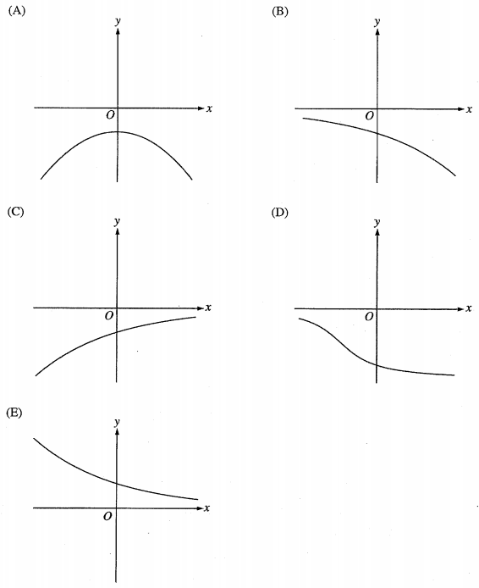

18. Given that, find the average rate of change of on the interval [1, 3]

(A) 6 (B) 13 (C)  (D)  (E) 

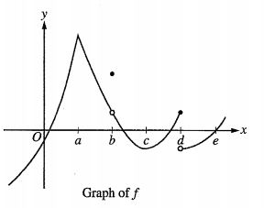

19. The graph of a function *f* is shown above. At which value of *x* is *f* continuous, but not differentiable?

(A) a (B) b (C) c (D) d (E) e

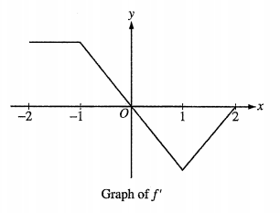

20. The graph of , the derivative of *f*, is shown above. Which of the following statements is true about *f*?

(A) *f* is decreasing for  (B) *f* is increasing for  (C) *f* is increasing for 

(D) *f* has a local minimum at  (E) *f* is not differentiable at 

21. The function *f* is continuous for  and differentiable for . If  and , which of the following statements could be false?

(A) There exists *c*, where , such that .

(B) There exists *c*, where , such that .

(C) There exists *c*, where , such that .

(D) There exists *c*, where , such that .

(E) There exists *c*, where , such that for all *x* on the closed interval .

22. The radius of a circle is increasing at a constant rate of 0.2 meters per second. What is the rate of increase in the area of the circle at the instant when the circumference of the circle is  meters?

(A) (B)  (C)  (D)  (E) 

23. For which of the following does exist?

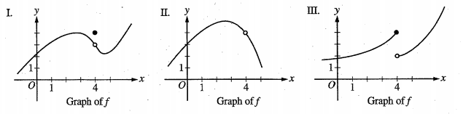

(A) I only (B) II only (C) III only (D) I & II only (E) I & III only

24. If , at what value of *x* does *f* attain its maximum value on the interval [0, 2]?

(A) ln 2 (B) ln 8 (C) ln 16 (D) 4 (E) nonexistent

25. Let *f* be the function with derivative given by . How many relative extrema does *f* have on the interval ?

(A) One (B) Two (C) Three (D) Four (E) Five

26. Let *f* be the function with a first derivative of  for . At what value of *x* does *f* attain its maximum value on the interval [0, 2]?

(A) 0 (B) 1.162 (C) 1.465 (D) 1.845 (E) 2

27. If , then *f* has which of the following relative extrema?

I. A relative maximum at .

II. A relative minimum at .

III. A relative maximum at .

(A) I only (B) III only (C) I & III (D) II & III (E) I, II, & III